Exp. 18 Configure a new VM

Aim:
To demonstrate Platform as a Service (PaaS) create and configure a new VM Image in any Public Cloud Service Provider.
Procedure:
- Sign in to Azure Portal
- Create a resource group
- Then create a virtual machine
- Allocate storage and ram for it
- Set username and passwords
- Download the RPD file by connecting the VM to the IP address\
- Use that RPD file to access the VM
Output:
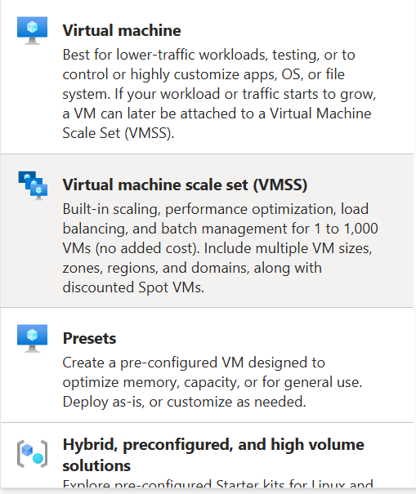

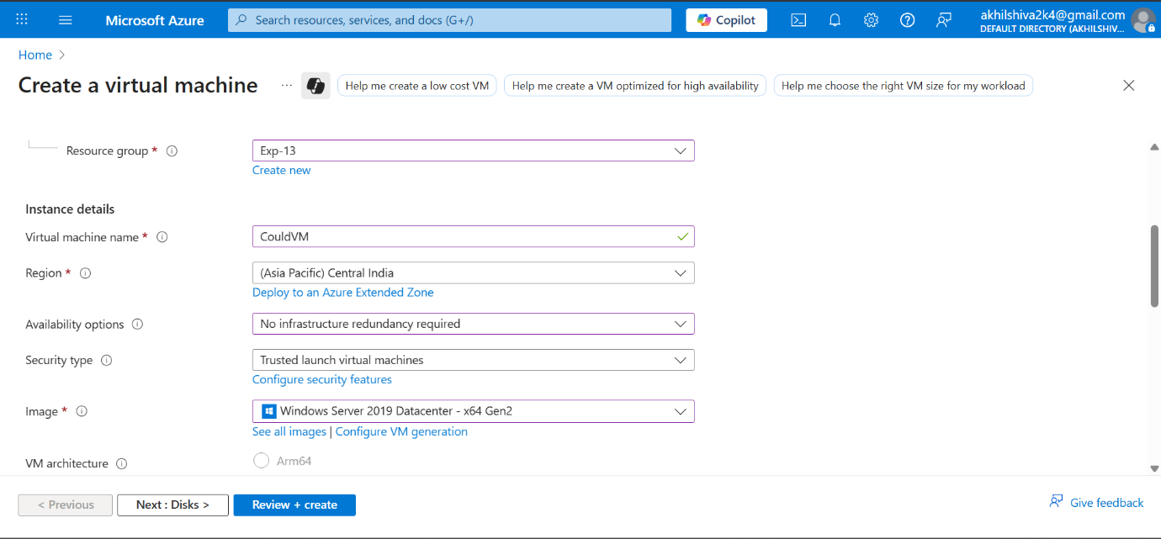
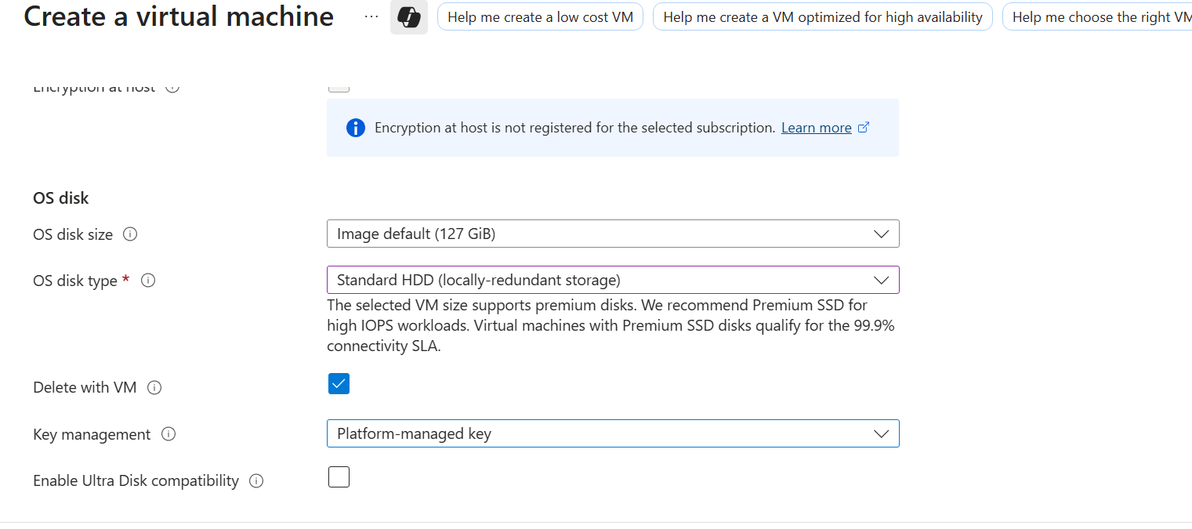
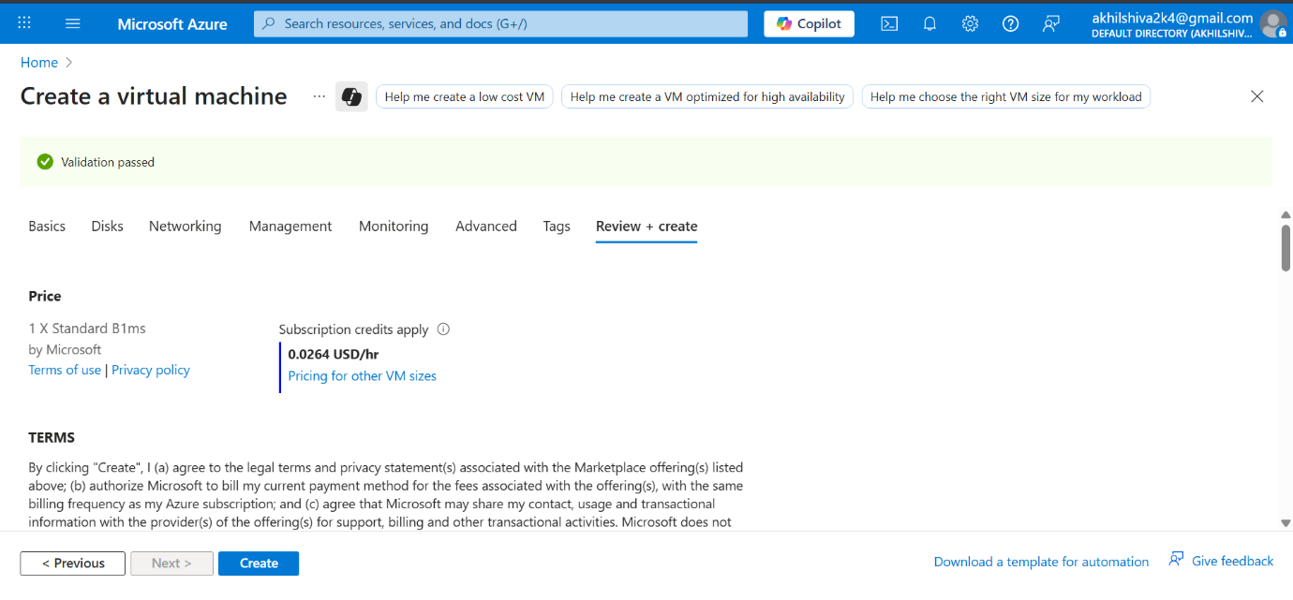

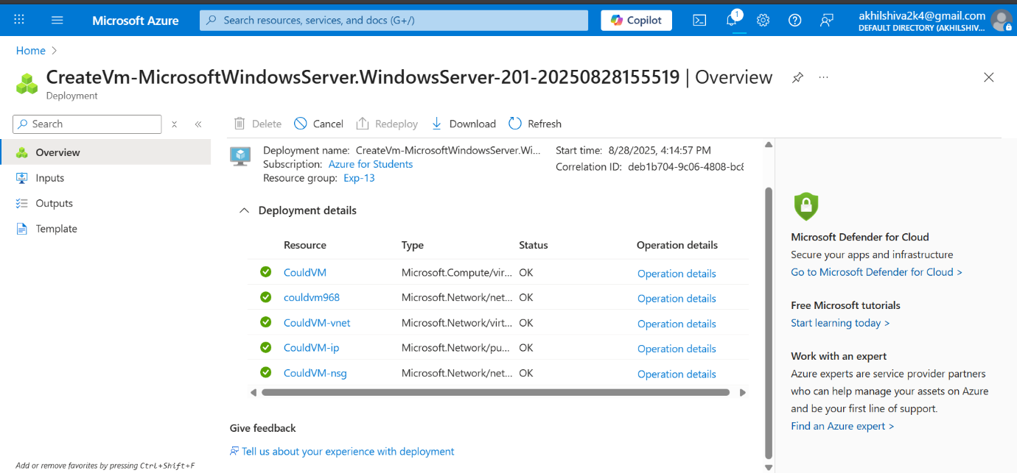

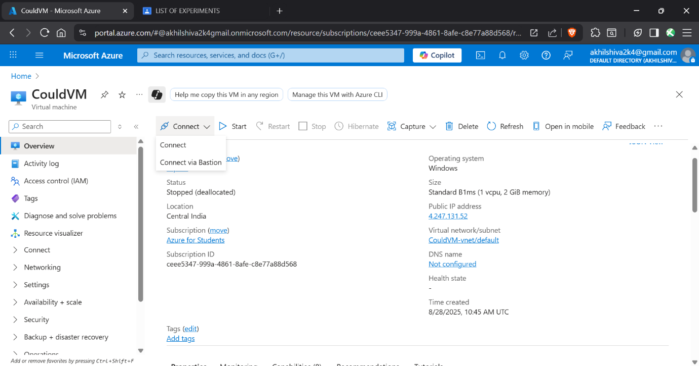
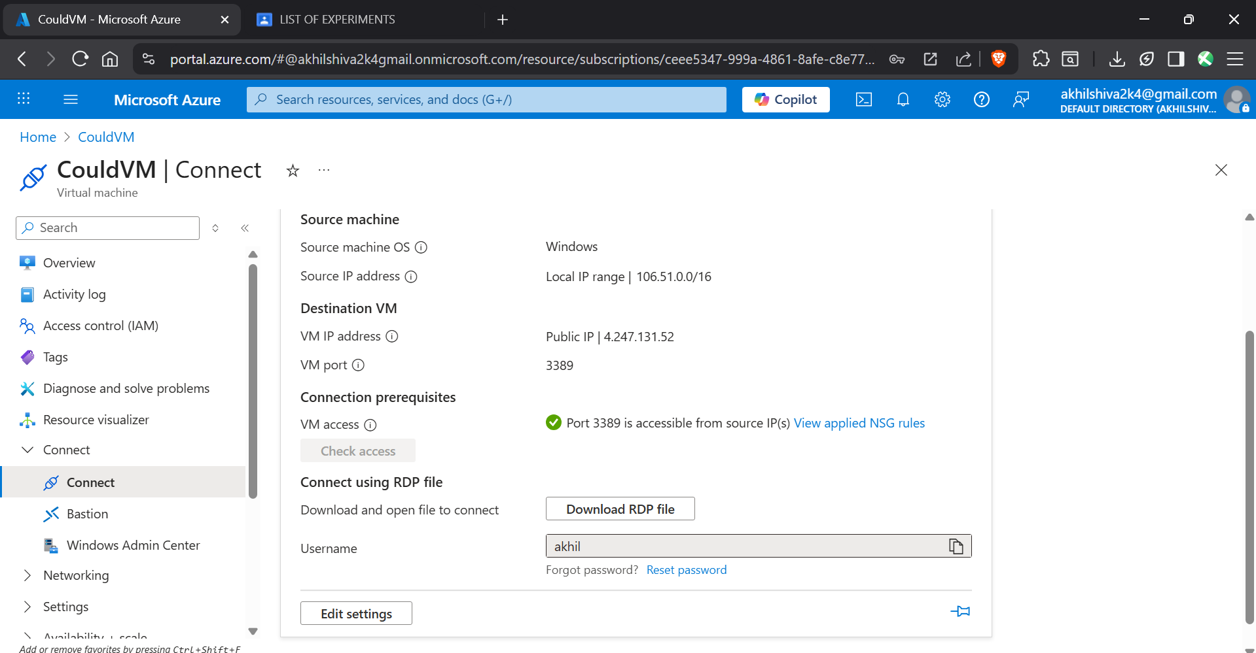
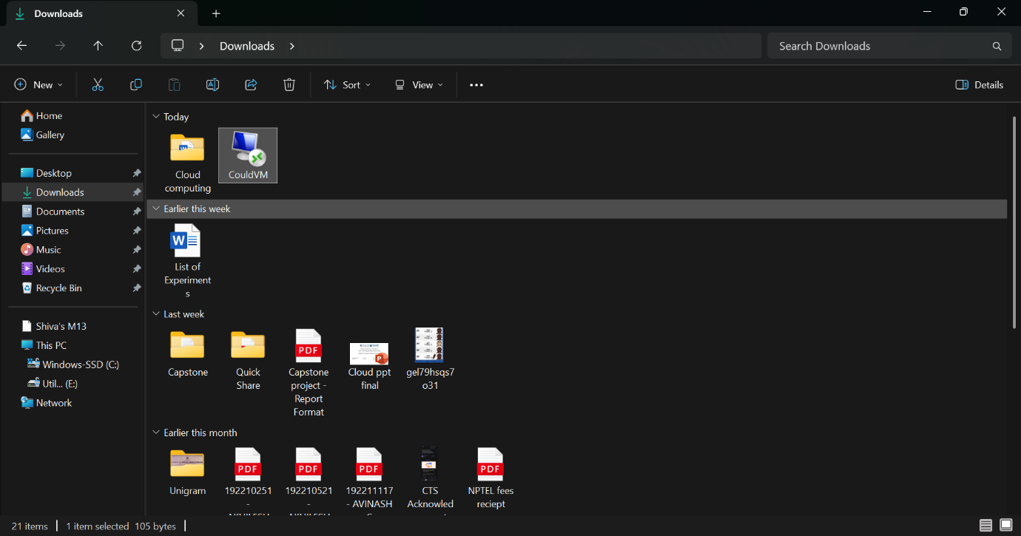
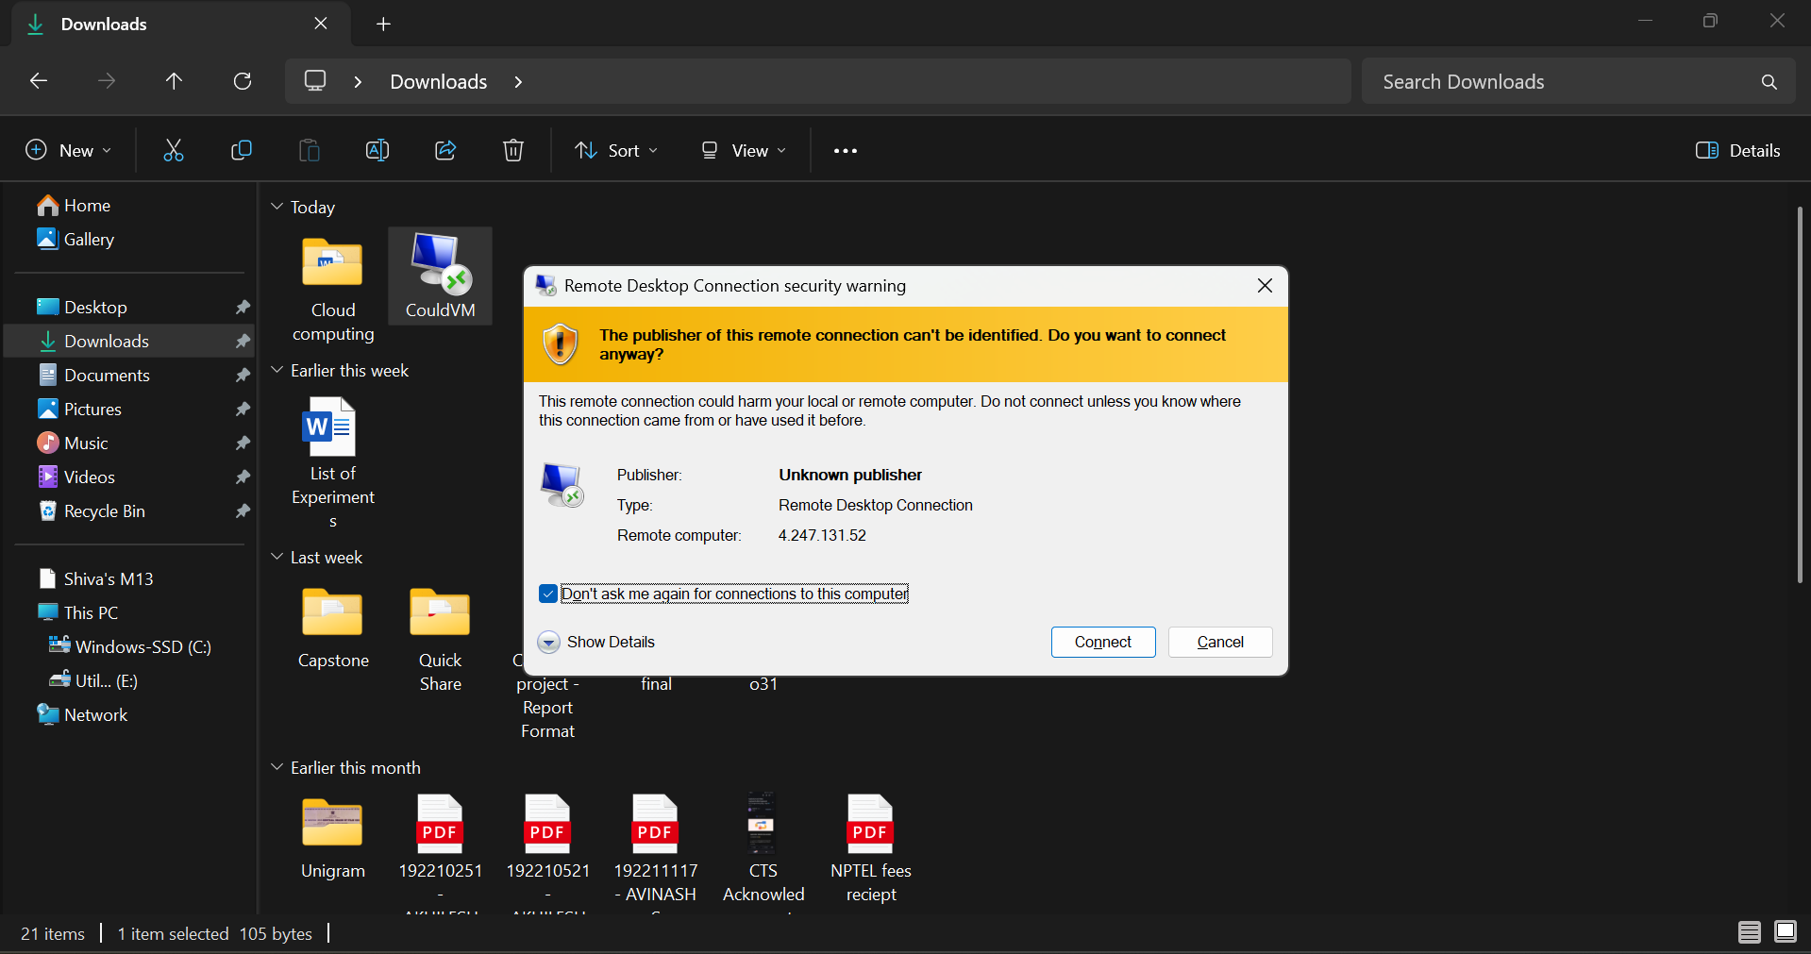
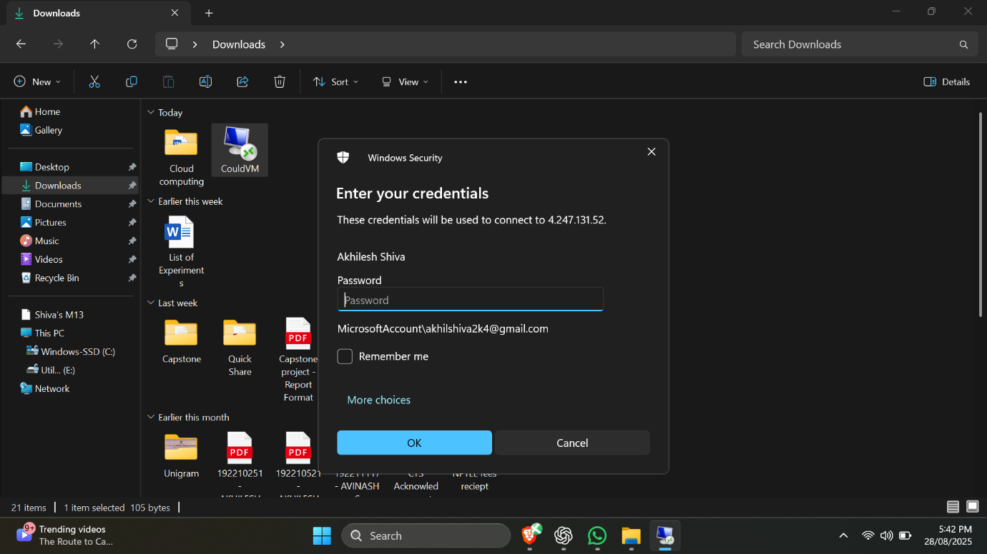
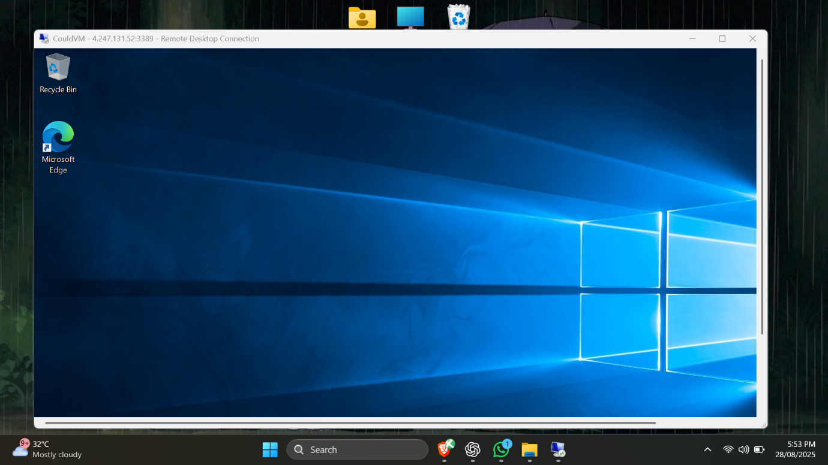

Result:
Thus the new VM was created and configured successfully

